Bridgestone to build Akron plant to make Firestone racing tires
Updated Feb 6; Posted Feb 6
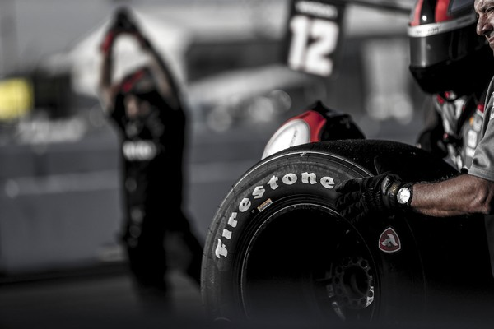
Bridgestone Americas announced it will build a new Firestone race tire manufacturing plant within the next four years. Firestone will continue to service as the sole tire supplier of the NTT IndyCar Series. (Photo courtesy of Bridgestone Americas)
1
By Brittany Nader, special to cleveland.com
brittany.nader1@gmail.com
AKRON, Ohio -- Bridgestone Americas announced plans Wednesday to build a plant in Akron to make Firestone race tires.
The new Bridgestone Advanced Tire Production Center will be across the street from the Bridgestone Americas Technical Center on East Firestone Boulevard.
All race-tire manufacturing will move to the new location over the next four years.
New construction and full renovation of an existing structure are included in the development of the new facility.
Plans to build the manufacturing plant are part of a five-year partnership extension between Firestone and NTT IndyCar Series.
Firestone will continue to serve as the official tire supplier of the Indianapolis 500 through 2025.
"The Akron community and race tire development have each played significant roles in our company's past, and they will continue to drive innovation for us in the future," Nizar Trigui, chief technology officer at Bridgestone Americas, said in a news release. "We are proud to ensure that Firestone race tires will be built in Akron for many years to come, soon in a new facility that will be as cutting edge as the tires it produces."
The new Bridgestone Advanced Technology Workshop is projected to produce its first Firestone Firehawk race tires for testing in the NTT IndyCar Series by the end of 2020.
Bridgestone will provide tire technology, on-track support, marketing and promotion of the NTT IndyCar Series as part of the brands' continued partnership.
"As the NTT IndyCar Series continues gaining momentum, we are introducing new fans to the Firestone brand and strengthening our relationship with the drivers who use our durable, dependable Firestone tires," Philip Dobbs, chief marketing officer, Bridgestone Americas Tire Operations, said in a news release.
The announcement of the five-year agreement and new manufacturing site was shared at an event in Indianapolis that featured racing legend Mario Andretti, and veteran IndyCar driver and team owner Ed Carpenter.
A second event was held at the Bridgestone Americas Technical Center in Akron with two-time Indy 500 winner Al Unser Jr.
"The trust I have always placed in Firestone was cemented [...] 50 years ago when I drove on the same right rear tire for the whole race, and it never let me down," Andretti said in a news release. "Firestone has always been a dependable partner, and I am excited to see its partnership with IndyCar continue."
Firestone has been the sole tire supplier of the NTT IndyCar Series for 20 consecutive seasons.
The company will produce and deliver more than 26,000 Firehawk race tires to teams throughout the upcoming 2019 schedule.

